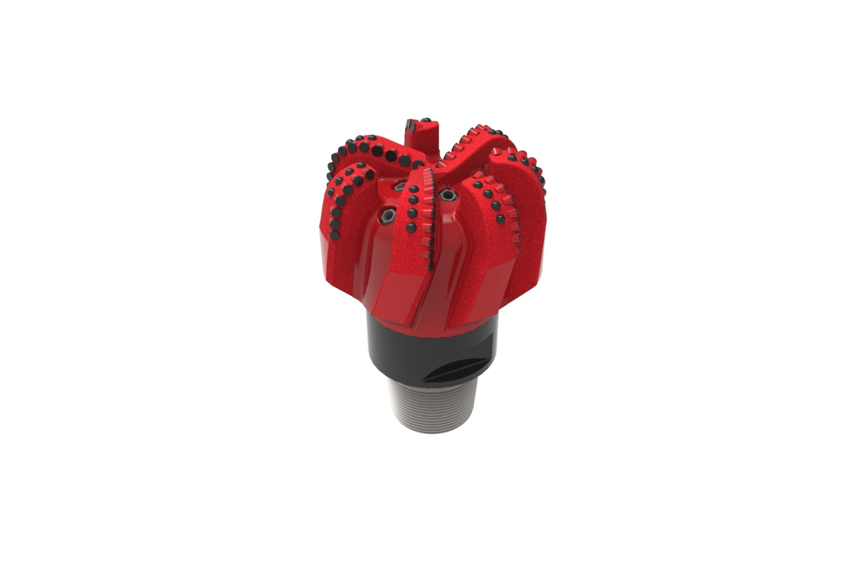
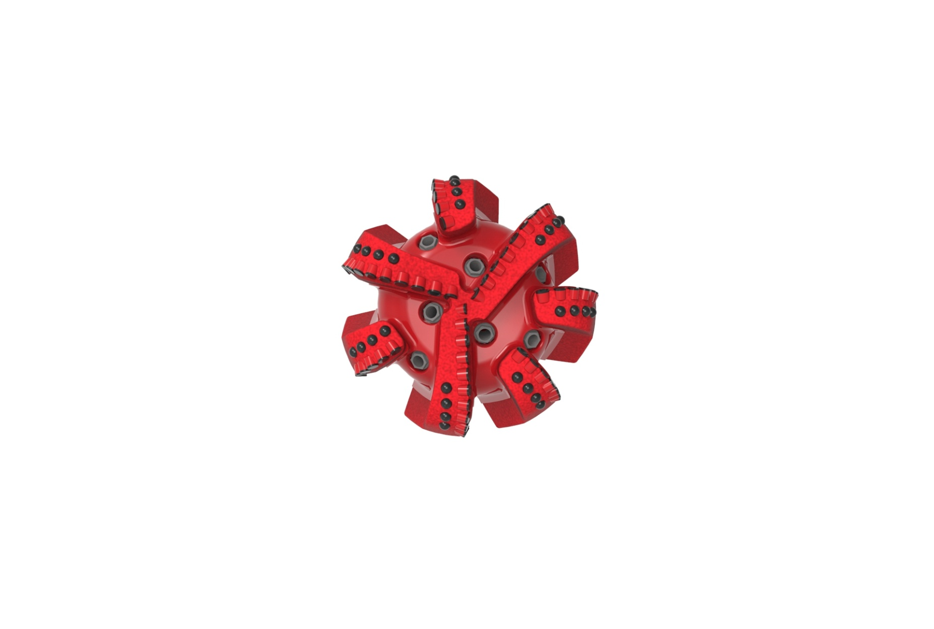

Drill Bit Specifications:
Cutter Size (Primary, Sec) | 5/8", 1/2"
Cutter Count (Total, Gage) | 65,10
Blade Count | 7
Gage Length (Inches) | 3.00
Nozzle Count (Primary, Sec.) | 7
Nozzle Series (Primary, Sec.) | 60
JSA (Sq. Inches) | 32.92
Max. TFA (Sq. Inches) | 2.60
Operating Parameters:
Max. Hydraulic Flow Rate (GPM) | 810
Max. Weight on Bit (1,000 Lbs.) | 60
Make-up Torque (ft/lbs) | 40,563
Nominal Dimensions:
Overall Length (Inches) | *17.87
Make Up Length (Inches) | *13.00
Bit Breaker | SKB-21011
Connection | Ø6-5/8" API Reg.
Approx. Weight (Lbs.)  *Long tool joint available upon request (adds 6” to fishing neck, makeup and overall length, and 64 lbs to approximate weight). | *220

Standard Features:

- Premium grade cutters maximize ROP and Life
- Large open face volume assists cuttings removal
- Seven nozzles optimize blade and cuttings removal

713-SR(K) Nomenclature Explained:

• | 7 | = | Number of blades
• | 13 | = | Primary Cutter Size (13mm)
• | SR | = | Single Row Cutters
• | 7 | = | Number of nozzles

*Interchangeable nozzles.

